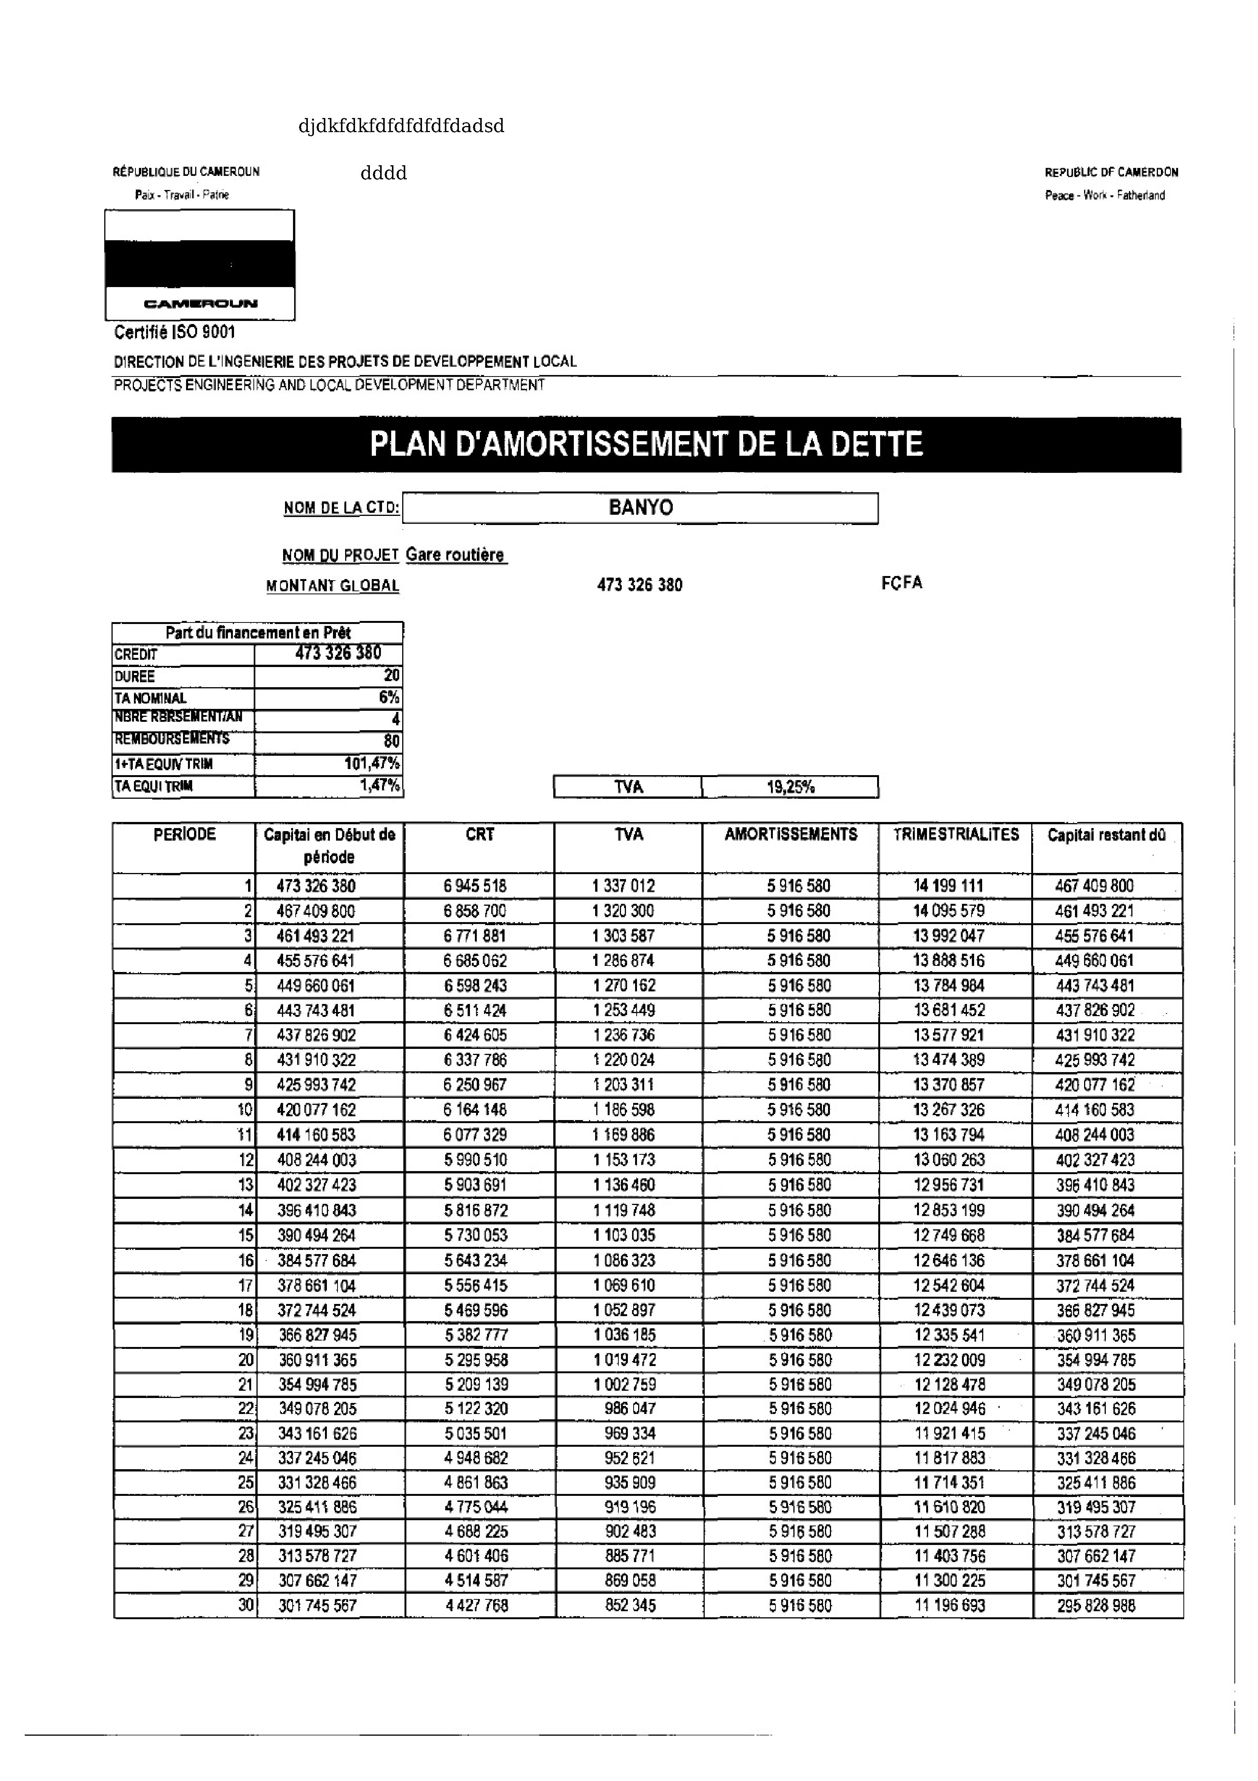

djdkfdkfdfdfdfdfdadsd

|  |  |  |
| --- | --- | --- |
| REPUBLIQUE DU CAMEROUN | dddd | REPUBLIC DF CAMERDON |
| Paix - Travail « Paine | Peace - Work - Fatherland |

CAMEAOUF   
Certifie ISO $001   
DIRECTION DE L’INGENIERIE DES PROWETS DE DEVELOPPEMENT LOCAL   
PROJECTS ENGINEERING AND LOCAL DEVELOPMENT DEPARTMENT

PLAN D'AMORTISSEMENT DE LA DETTE

|  |  |  |
| --- | --- | --- |
| NOM DE LA CTD:| | BANYO | | FCFA |
| NOM DU PROJET Gare routiere | 473 326 380 |
| MONTANT GLOBAL |

du financement en

|  |  |  |  |  |  |
| --- | --- | --- | --- | --- | --- |
| PERIODE | Capital en Début de | |  CRT | TVA | | 19,25% | | TRIMESTRIALITES | Capital restant dd - |
| TVA | AMORTISSEMENTS |

période

|  |  |  |  |  |  |  |  |
| --- | --- | --- | --- | --- | --- | --- | --- |
| 1] | 473 326 380 | 6 945 518 | 1337 012 | 5 916 580 | 14.199 114 | © | 467 405 800 |
| Z| | 467409800 | 6 858 700 | 1 320 300 | 5 916 580 | 14.095 579 | 461 493 221 |
| 3] | 461493 221 | 6 771 881 | 1 303 587 | 5 916 580 | 13 992 047 | 455 576 641 |
| 4| | 455576 641 | § 685 062 | 1 286 874 | 5 916 580 | 13 888 516 | 449 660 061 |
| 5} | 449660061 | 6 598 243 | 1 270 162 | 5916 580 | 13 784 984 | 443 743 481 |
| 6] | 443 743 481 | 6511 424 | 1 253 449 | 5 916 580 | 13 681 452 | 437 826 802 © |
| f| | 437826 902 | 6 424 605 | 1236 736 | 5 916 580 | 13577 921 | 431910 322 |
| BE | 431910 322 | 6 337 786 | 1 220 024 | 5916 580 | 13 474 389 | 425 993 742 |
| S| | 425.993 742 | § 250 967 | #203 311 | 5 916 580 | 13 370 857 | 420 O77 162 |
| 10} | 420077 162 | 6 164 148 | 1 186 598 | 5 916 580 | 13 267 326 | 414 160 583 |
| Ff | 414160583 | 6 O77 329 | 1 4169 886 | 5 916 580 | 13 163 794 | 409 244003 |
| 12) | 408 244 903 | § 990 510 | 1 153 173 | 5 916 580 | 13.060 263 | 402 327 423 |
| 13} | 402327 423 | § 803 691 | 1 136.460 | 5 916 580 | 12956 731 | 396 410 843 |
| 14] | 396.410 843 | 5 816 872 | 1119 748 | 5 916 580 | 12853 199 | 390 494 264 |
| 15] | = 390 494 264 | § 730 053 | 1103 035 | 5 916 580 | 12749 668 | 384 577 684 |
| 16] | - 384577 684 | 5 643 234 | 1 086 323 | 5 916 580 | 12 646 136 | 378 661 104 |
| V7] | 378661 104 | § 556 415 | 1 069 610 | 5 916 580 | 12542 604 | 372 F744 524 |
| 18} | 372744 524 | 6 489 596 | 1 052 897 | 5 916 580 | 12439 073 | 366 827 945 |
| 19| | 366 627 945 | § 382 777 | 1036 185 | 5916 580 | 12 335 $41 | -360 911 365 |
| 20; | 360911 365 | 5 295 958 | 1019 472 | 5916 580 | 12232 009 | 354 994 785 |
| 21} | 364 994 785 | § 209 139 | 1002 759 | 5 916 580 - | 12128 478 | 349 078 205 |
| 22; | 349078 205 | 5 122 320 | 986 047 | 5 916 580 | 12 024 946 - | 343 161 626 |
| 23, | 343 161 626 | 5035 501 | 969 334 | 5916 580 | 19921415 | 337 245 046 |
| 24, | 337 245 046 | 4948 682 | 952 621 | 5916580 | 11 847 883 | 331 328 466 |
| 25| | 331328 466 | 4861 863 | 935 909 | 5916 580 | 11714 351 | 325 411 886 |
| 26) | 325.444 S86 | 4775 044 | 949 196 | 5946 580 | 441610 320 | 319 495 307 |
| 27| | 319495 307 | 4688 225 | 902 483 | 5 916 580 | 11 507 288 | 313 578 727 |
| 28) | 343576 727 | 4604 406 | 885 771 | 5916 580 | 14 403 756 | 307 662 147 |
| 29; | 307 662 147 | 4514 587 | 869 058 | 5916 580 | 14300 225 | 301 745 567 |
| 30} | 301 745 587 | 4427 768 | 852 345 | 5 916 580 | 11 196 693 | 295 828 988 |

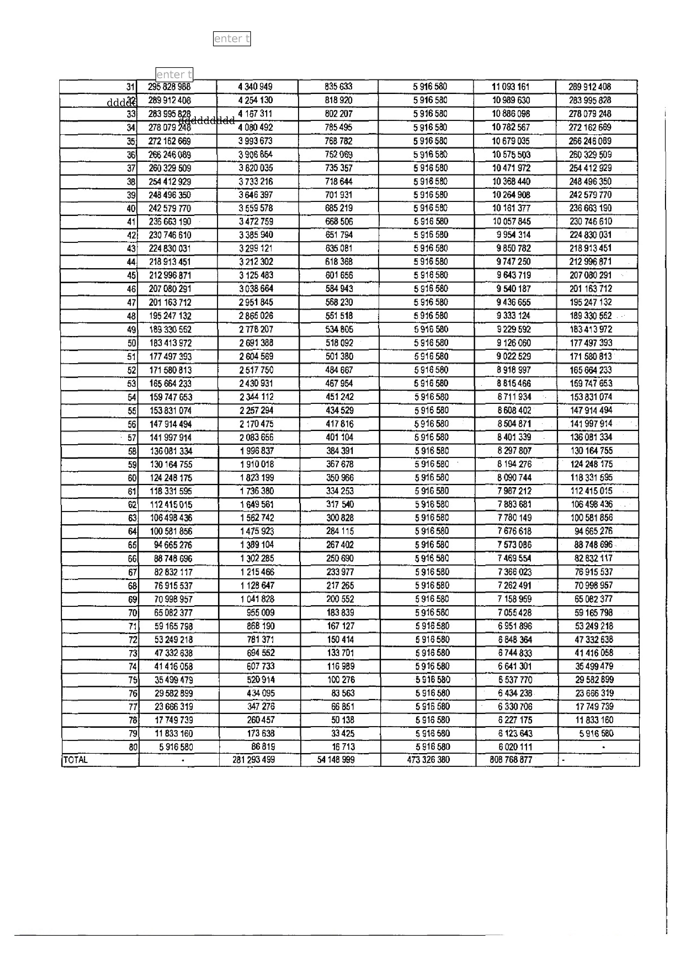

lenter

|  |  |  |  |  |  |  |  |  |  |  |
| --- | --- | --- | --- | --- | --- | --- | --- | --- | --- | --- |
| TOTAL | 31] | | enter 295 828 968 | 4 340 949 | | 835 633 | 5 916 580 | 11093 161 | 289 942 408 | . - |
| dddda@ | | 289912 408 | 4 254 130 | | B18 920 | 5 916 580 | 40 989 630 | 283 995 828 |
| 33] | | 283995878... | | |. 4187 311 | 802 207 | 5 946 580 | 10-886 098 | 278 079 248 |
| 34| | | 278079248 | ~=6| ~—~—«-4: 080492 | | 785 495 | 5 916 580 | 10.782 567 | 972 162 669 |
| 35) | | 272 162 669 | 3993 673 | | 768 782 | 5 916 580 | 10 679 035 | 266 246 089 |
| 36) | | 266 246.089 | 3.906 854 | | 752 089 | 5 916 580 | 10 75 503 | 260 329 509 |
| 37| | | 260 329 509 | 3 820 035 | | 735 367 | 5 916 580 | 40 4741 972 | 254 412 929 |
| 38| | | 254412929 | 3733 216 | | 718 644 | 5 916 580 | 10 368 440 | 248 496 350 |
| 39| | | 248 496 350 | 3646 397 | | 701 931 | 5 946 580 | 10 264 908 | 242 579 770 |
| 40| | | 242579770 | 3 559 578 | | 685 219 | 5 946 580 | 40 181 377 | 236 663 190 |
| 4i| | | 236663190 - | 3472 759 | | 668 506 | 5 916 580 | 10 057 845 | 230 746 610 |
| 42} | | 230 746 610 | 3385 940 | | 851 794 | 5 916 680 | 9954 314 | 294 830 031 |
| 43} | | 224830 031 | 3.299 121 | | 635 081 | 5 946 580 | 9 850 782 | 218913 451 |
| 44] | | 218913 451 | 3.212 302 | | B18 368 | 5 946 580 | 9747 250 | 212 996 671 |
| 45] | | 212996871 | 3 125 483 | | 601 656 | 5 916 580 | 9 643 719 | 207 080 291 |
| 46| | | 207 080 291 | 3.038 664 | | 584 943 | 5 916 580 | 9 540 187 | 201 163 712 |
| 47] | | 201 163712 | 2951 845 | | 568 230 | 5 946 580 | 9 436 655 | 195.247 132 |
| 48| | | 195 247 132 | 2 866 026 | | 551 518 | 5 946 580 | 9 333 124 | 189 330 562 |
| 49| | | 189 330 562 | 2778 207 | | 534 805 | § 946 580 | 9229 592 | 183.413 972 | |. |
| 50| | | 183.413 972 | 2 691 388 | | 518 092 | 5 9416 580 | 9 126 060 | 177 497 393 |
| 54] | | 177497 393 | 2 604 589 | | 501 380 | § 916 580 | 9 022 529 | 171 580 813 |
| 52| | | 171580813 | 2517 750 | | 484 B67 | 5 916 580 | 8 918 997 | 185 664 233 |
| 53| | | 165 664 233 | 2.430 931 | | ABT 954 | 5 916 580 | B 815 486 | 159 747 653 |
| 54] | | 159 747 653 | 2.344 112 | | 451 242 | 5 916 580 | 8711934 | 153.831 074 |
| 55| | | 153831 074 | 2 257 294 | | 434 529 | 5 916 §80 | 8.608 402 | 147 914 494 |
| 56] | | 147 914 494 | 2170475 | | 417 816 | 5 916 580 | 8.504 871 | 441 997 914 |
| ” | §7| | 141997 994 | 2 083 656 | | 401 104 | 5 916 580 | B 401 339 | 136 081 334 |
| §8] | | 136081 334 | 1 996 837 | | 384.391 | 5 916 580 | 8 297 807 | 130 164 755 |
| 59] | | 130 164 755 | 1910018 | | 367 678 | 5916580 - | B 194 276 | "424 248 178 |
| Bol | | 124 248 176 | 1 873 199 | | 350 966 | 5 916 580 | B 090 744 | 118 331 695 |
| 61] | | 148 331595 | 4 736 380 | | 334 253 | 5 916 580 | 7 987 212 | 12415015 |
| 62) | | 112415015 | 1 649 564 | | 347 540 | 5 916 580 | 7 883 681 | 106 498435 |
| 63} | | 106498 436 | 1 562 742 | | 300 828 | 5916 580 | 7 780 149 | 100 581 856 |
| 64| | | 100 581 856 | 1475 923 | | 284 115 | 5 916 580 | 7 676 618 | 94 665 276 |
| 65] | | 94665 276 | 1 389 104 | | 267 402 | 5 916 580 | ¥ §73 086 | 88 748 696 . |
| 66| | | 88748 696 | 1302 285 | | 250 690 | 5 916 580 | 7 469 554 | 82 832 117 |
| 67| | | 82832 117 | 1 215 466 | | 233 977 | 5 916 580 | 7366 023 | 78 915 537 |
| 68] | | 76918537 | 1 128 647 | | 217 265 | 5 916 §80 | 7 262 491 | 70 998 957 |
| 69] | | 70998 957 | 1 041 828 | | 200 552 | 5 916 580 | 7 158 959 | 65 082 377 |
| 70] | | 65082377 | 955 009 | | 183 839 | 5916 580 | 7 065426 | 59 165 798 |
| 71] | | 59165798 | 868 190 | | 167 127 | § 918 580 | 6 951 896 | §3 249 218 |
| 72| | | 63.249 218 | 781 371 | | 150 414 | 6 916 580 | 8 B48 364 | 47 332 638 |
| 73| | | 47 332.838 | 694 552 | | 133 701 | 5918 680 | 8 744 833 | 41416058 |
| 74| | | 41416058 | 607 733 | | 116 989 | 5916 580 | 6 641 201 | 35499479 |
| 76) | | 35.499 479 | 520944 | | 400 276 | 5 916 580 | 6 537 770 | 29 582 899 |
| 76] | | 29582899 | 434 095 | | 83 563 | 5 916 580 | 6 434 238. | 23.656 319 |
| 77] | | = 23 666.319 | 347 276 | | 66 851 | 5,916 580 | 6 330 706 | 17 749 739 |
| 781 | | 17 749.739 | 260 457 | | 50 138 | 5 916 580 | § 297 175 | 11.833 160 |
| 791 | | 11.833 160 | 173 638 | | 93 425 | 6 918 580 | 8 123 643 | 5916 580 |
| go] | | § 916580 | 86 819 | | 16 713 | 5 916 580 | 6.020111 | . |
| i | 281 293 499 | | 54 148 999 | 473 326 380 | B08 768 877. |